I, _**Trupthi Ladda** submit my resume and qualifications for the _ **Full Stack Developer** role with American Airlines Fieldglass Job Posting ID#: AAJP00009165

I have not submitted my resume or an application for this specific position to any other staffing supplier within the last thirty (30) days, nor have I signed a Right to Represent form with another staffing supplier for this job requisition.

Additionally, I understand that by signing this form I am also expressing my commitment to adhere to the onsite requirements for the aforementioned position as outlined in the job posting, should I accept an offer for this role at American Airlines. I am acknowledging that the requirements have been explained to me by the staffing supplier and my submission to this position confirms my acceptance of these requirements, if applicable.

**Notice**: I understand that by executing a Right-to-Represent form via electronic, verbal, or written means for the same requisition with more than one staffing supplier that I will be removed from further consideration for this role.

Date:

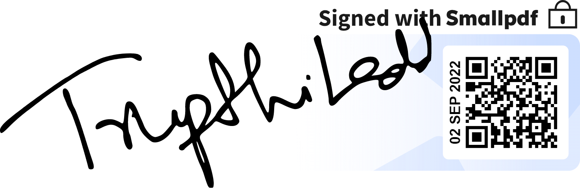Signature: